Module Name: Checkout / Billing Address – ZIP / Postal Code Validation
Webpage URL: https://demo.nopcommerce.com/
Test Case ID: TC001

Test Case Description: To test invalid ZIP / Postal Code handling in nopCommerce and document how the existing issue from Practical 5 is managed through TestLink and Bugzilla.

Scenario ID: a1
Scenario: Bugzilla Home Page Access
Test Steps:
1. Open an authorized Bugzilla instance in the browser.
2. Observe the Bugzilla home page.
3. Verify that the main bug-tracking options are displayed.
4. Verify that bug search and reporting options are available.
Screenshots:
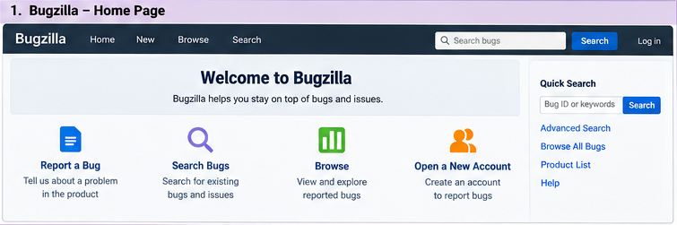
Scenario ID: a2
Scenario: Report the ZIP / Postal Code Defect
Test Steps:
1. Open the authorized Bugzilla instance and check whether the existing defect is already present.
2. Open the New Bug page only if a new report is appropriate and not a duplicate.
3. Select Product: nopCommerce and Component: Checkout / Billing.
4. Enter the summary: Invalid characters accepted in ZIP / Postal Code field.
5. Enter the description explaining that ABC@@ was accepted and saved as the postal code.
6. Set severity to Medium and priority to High, as recorded in Practical 5, then submit only in the authorized
Screenshots:
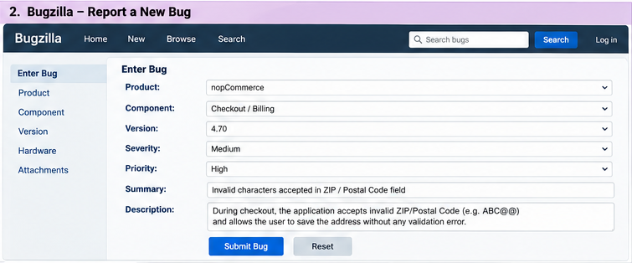
Scenario ID: a3
Scenario: View Reported Bugs
Test Steps:
1. Open the bug list in the authorized Bugzilla instance.
2. Search for the ZIP / Postal Code validation defect.
3. Verify the displayed bug ID and summary.
4. Verify the product, component, status, severity, and priority..
Screenshots:
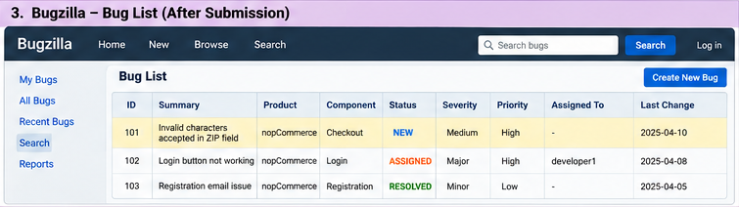

Scenario ID: a4
Scenario: Verify Bug Details
Test Steps:
1. Open the ZIP / Postal Code defect from the bug list.
2. Verify its summary and description.
3. Verify Product and Component.
4. Verify Severity, Priority, Status, and assignee.
5. Confirm that the details match the issue reported in Practical 5.

Screenshots:
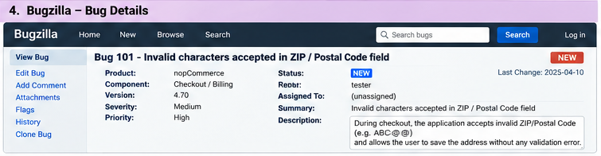
Scenario ID: b1
Scenario: TestLink Project Home
Test Steps:
1. Open the authorized TestLink instance and sign in.
2. Observe the TestLink home or project page.
3. Verify the project tree.
4. Select the nopCommerce project.

Screenshots:
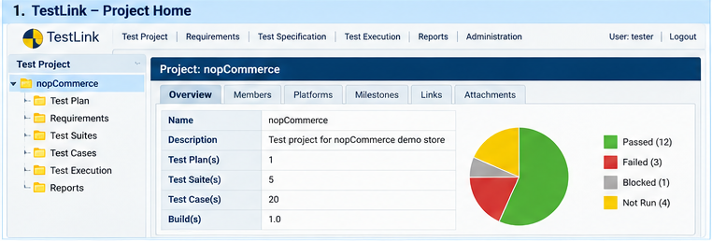

Scenario ID: b2
Scenario: Create Test Case for ZIP / Postal Code Validation
Test Steps:
1. Open the nopCommerce project in TestLink.
2. Open or create the Checkout test suite.
3. Create test case ID TC001 with the title Verify ZIP / Postal Code validation in checkout.
4. Enter the precondition that the billing address form is displayed.
5. Add the test steps using invalid input ABC@@ and the expected validation result.
6. Save the test case.

Screenshots:
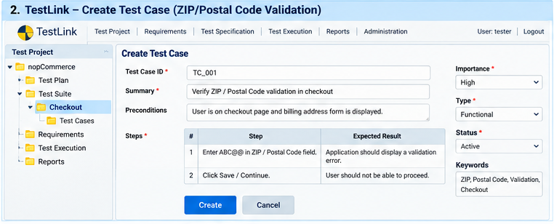
Scenario ID: b3
Scenario: Execute Test Case TC001
Test Steps:
1. Open the TestLink execution section.
2. Select the nopCommerce test plan, build, and test case TC001.
3. Open the nopCommerce checkout and enter ABC@@ in the ZIP / Postal Code field.
4. Enter the remaining required billing details and attempt to save or continue.
5. Record the actual behavior in TestLink and choose Pass or Fail based on the observed result.
Screenshot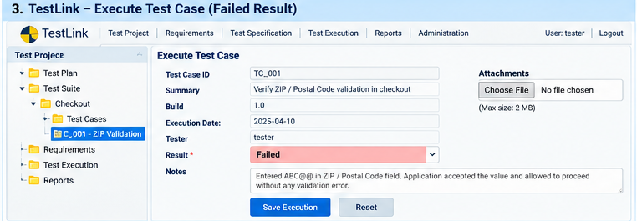s:

Scenario ID: b4
Scenario: View Test Execution Report
Test Steps:
1. Open the Reports section in TestLink.
2. Open the execution report for the relevant test plan.
3. Verify the test case ID and summary.
4. Verify the displayed status and actual-result notes.
5. Check the report totals and export the report if the instance supports it.

Screenshots:
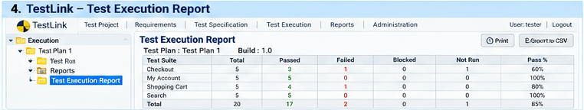

Observation
The previous Practical 5 report records that the nopCommerce checkout accepted ABC@@ as the ZIP / Postal Code and saved it in the billing address. That prior finding is the basis for this Practical 8 TestLink/Bugzilla workflow. The interface images are provided as visual examples; use actual application captures for final execution evidence.
Output

TestLink: Images are placed inline with the corresponding scenarios for project home, test-case creation, test execution, and execution report.
Bugzilla: Images are placed inline with the corresponding scenarios for home page, new bug form, bug list, and defect details.
Defect Reference: BUG-001 is the identifier recorded in the previous Practical 5 report. Confirm it against the current Bugzilla instance before relying on it as a live server ID.
Conclusion / Outcome
This report follows the supplied Practical 8 reference structure and uses nopCommerce as the application under test. The previously documented ZIP / Postal Code defect is carried forward for TestLink and Bugzilla workflow practice. Before treating this as a completed live practical, execute the steps in authorized instances, capture genuine screenshots, verify the defect ID/status, and update actual results and pass/fail totals.

